Practical - 1
Practical Title: Project Initiation, Requirement Analysis, Sitemap, Wireframe, and GitHub Setup

Problem Definition: Initiate the semester-long StudentHub portal by identifying the problem scope, user roles, key modules, navigation flow, and minimum 10 pages.

Create a sitemap, low-fidelity wireframe, project folder structure,

README file, and GitHub repository.

What is URL and parts of URL?
Answer: A URL (Uniform Resource Locator) is the address used to locate and access a resource on the Internet, such as a webpage, image, video, or file. A URL generally consists of several parts: protocol (such as http or https) specifies how the browser communicates with the server; domain name identifies the website or server; port number specifies the communication port, if required; path identifies the specific page or resource on the server; query string contains additional parameters or information sent to the server; and fragment identifies a specific section within a webpage. For example, in https://www.example.com:8080/products?id=10#details, https is the protocol, www.example.com is the domain name, 8080 is the port, /products is the path, ?id=10 is the query string, and #details is the fragment.

How does HTML file process in web browser?
Answer: When an HTML file is opened in a web browser, the browser first reads and parses the HTML code to understand the structure of the webpage. It then creates a DOM (Document Object Model) from the HTML elements. If the HTML file contains CSS, the browser processes the CSS to determine the appearance and layout of the elements. If JavaScript is included, the browser executes it to provide dynamic behavior. The browser then combines the HTML and CSS information, calculates the layout, and renders the webpage on the screen. If the HTML contains external resources such as images, videos, CSS files, or scripts, the browser also requests and loads those resources from the specified locations.

3. How will page navigation flow managed among all HTML pages?
Answer: Page navigation among HTML pages is managed using hyperlinks (<a> tags). Each HTML page contains links that specify the location of another page using the href attribute. When a user clicks a link, the browser loads the specified HTML page, allowing the user to move from one page to another. For example, <a href="about.html">About Us</a> navigates from the current page to about.html. Navigation can be organized through a navigation bar or menu containing links to important pages such as Home, About, Services, and Contact. In this way, all HTML pages are connected and the user can easily move between them.

4. How will GitHub commits be maintained after each practical?
Answer: GitHub commits are maintained after each practical by saving the completed practical files in a local Git repository and then recording the changes using a commit. After completing a practical, the files are added using git add, a meaningful commit message is written using git commit, and the changes are uploaded to the GitHub repository using git push. Each practical should have a separate commit with a clear message, such as “Practical 1 completed” or “Added HTML navigation page”. This maintains a proper history of all practicals and makes it easy to track changes and previous versions of the work.

5. Project Initiation
Project initiation is the first phase of software development where the project idea isidentified, objectives are defined,
scope is decided, and basic planning is performed before actual development begins.

6. Requirement Analysics
Requirement analysis is the process of collecting, understanding, and documenting the needs and expectations of users for a software system.
It helps developers understand what the system should do before starting implementation.

7. Sitemap
A sitemap is a visual representation of the structure and navigation flow of a website. It shows the relationship between different pages.

8.Wireframe
A wireframe is a basic visual layout of a website or application that represents the arrangement of elements on a page without focusing on
colors, images, or detailed design.

Wireframe :
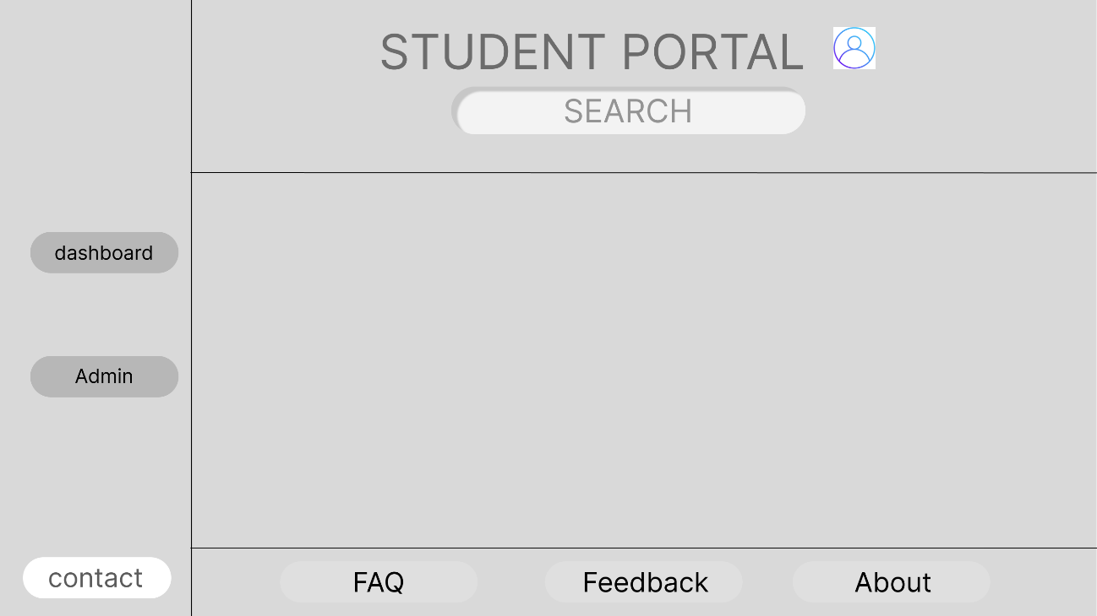

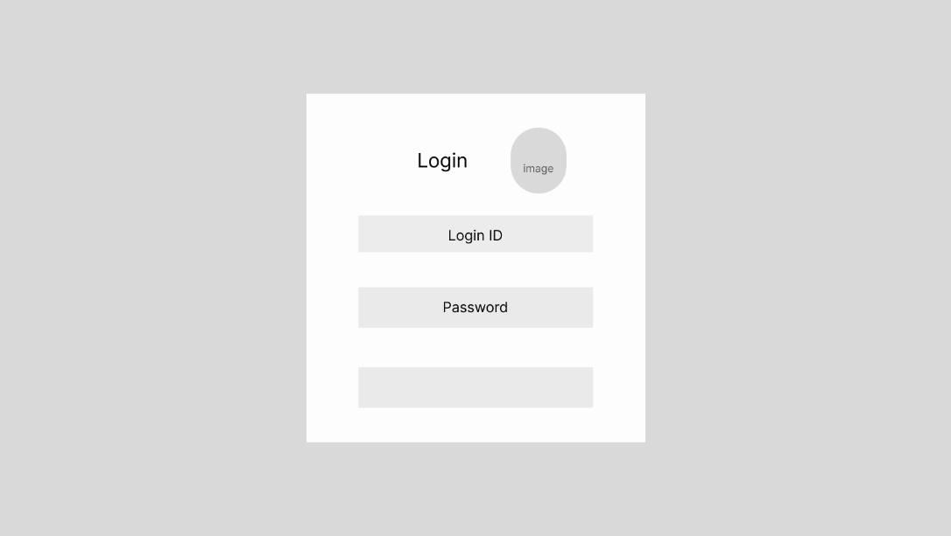
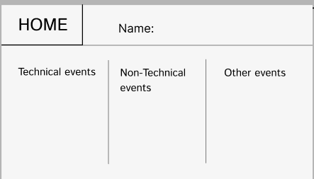

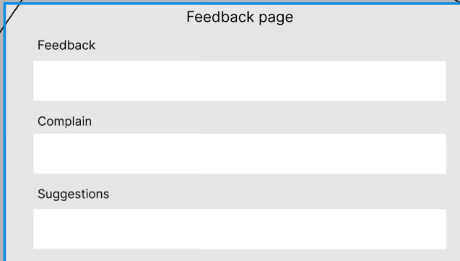
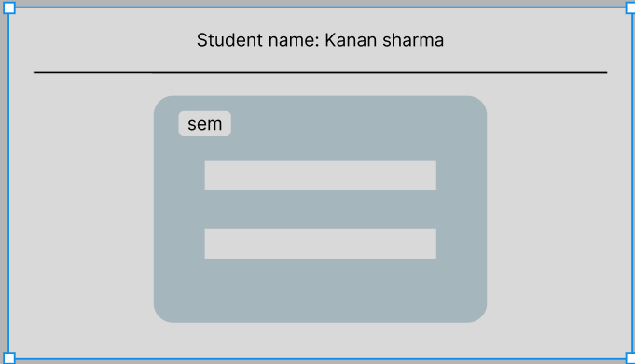

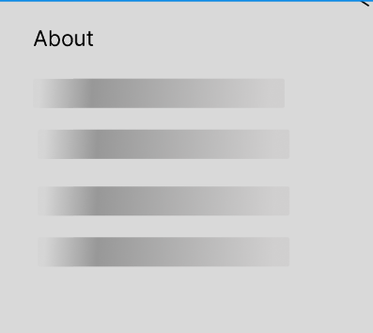

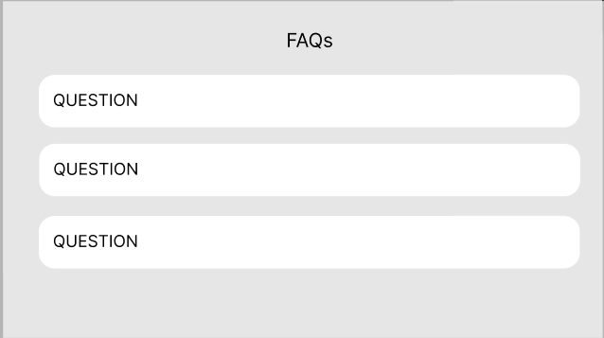

GitHub Repository Link:

https://github.com/kanan2007s-sys/Web-development-

Challenges Faced:
The main challenge was to place crucial option on right place for easy navigation.

Learning Outcomes:

I can make wireframe and sitemap of websites .

Faculty Remarks:

